Chapter 13, Solution 76.

Using Fig. 13.138, design a problem to help other students to better understand a wye-delta, three-phase transformer and how they work.

Although there are many ways to solve this problem, this is an example based on the same kind of problem asked in the third edition.

Problem

A Y-Δ three-phase transformer is connected to a 60-kVA load with 0.85 power factor (leading) through a feeder whose impedance is 0.05 + j0.1Ω per phase, as shown in Fig. 13.137 below. Find the magnitude of:

(a) the line current at the load,

(b) the line voltage at the secondary side of the transformer,

(c) the line current at the primary side of the transformer.

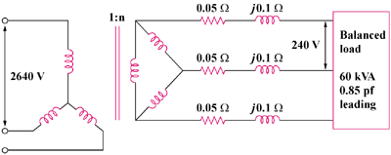

Figure 13.137

Solution

(a) At the load, V_{L} = 240 V = V_{AB}

V_{AN} = V_{L}/ = 138.56 V

Since S = V_{L}I_{L} then I_{L} = 60,000/(240) = 144.34 A

1:n
2640V
240V
C

Balanced
Load
60kVA
0.85pf
leading
B
A
j0.1 Ω
0.05 Ω
j0.1 Ω
0.05 Ω
j0.1 Ω
0.05 Ω

(b) Let V_{AN} = |V_{AN}|∠0° = 138.56∠0°

cosθ = pf = 0.85 or θ = 31.79°

I_{AA’} = I_{L}∠θ = 144.34∠31.79°

V_{A’N’} = ZI_{AA’} + V_{AN}

= 138.56∠0° + (0.05 + j0.1)(144.34∠31.79°)

= 138.03∠6.69°

V_{Ls} = V_{A’N’} = 138.03 = 239.1 V

- For Y-Δ connections,

n = V_{Ls}/V_{ps} = x238.7/2640 = 0.1569

f_{Lp} = nI_{Ls}/ = 0.1569x144.34/ = 13.05 A

